Part1

Implement the Discriminator of the DCGAN

1. Here we use ceiling for padding.

For first layer

(32 – 5 + 2P)/2 + 1 = 16

Padding = 2

For second layer

(16 – 5 + 2P)/2 + 1 = 8

Padding = 2

For third layer

(8 – 5 + 2P)/2 + 1 = 4

Padding = 2

For forth layer

(4 – 5 + 2P)/2 + 1 = 1

Padding = 1

Experiment

200 iterations 5000 iterations

From above images, it is easy to figure out that the emoji it generates after 5000 iterations is much clearer than the 200 iterations one and it looks more like a real emoji.

Part2

CycleGAN Experiments

1.

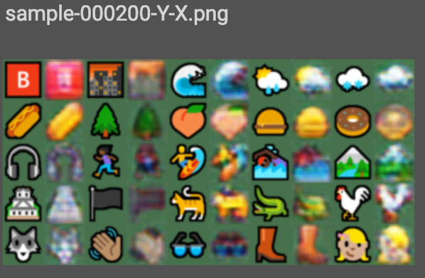

200 iterations of X-Y 200 iterations of Y-X

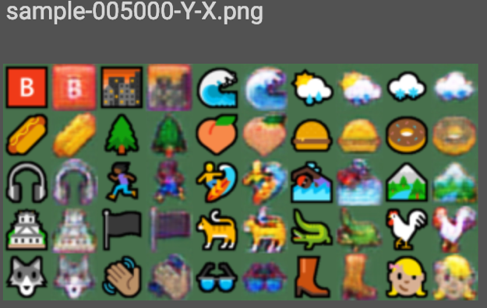

5000 iterations of X-Y 5000 iterations of Y-X

2.

200 iterations of X-Y

From the above pictures, after changing the seed, the most noticible difference is that the color was changed.

3.

lambda_cycle = 0:

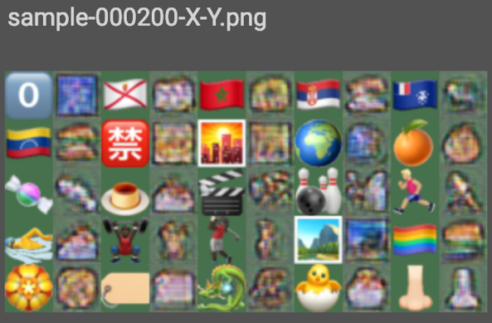

200 iterations of X-Y 200 iterations of Y-X

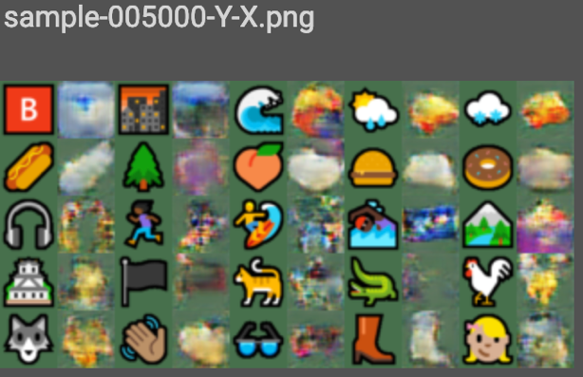

5000 iterations of X-Y 5000 iterations of Y-X

As we can see here if without the cycle-consistency loss, the emoji it generates is not really well.

lambda_cycle = 0.1

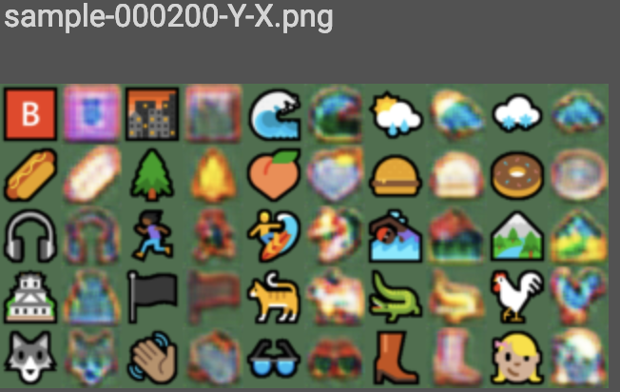

200 iterations of X-Y 200 iterations of Y-X

5000 iterations of X-Y 5000 iterations of Y-X

We can see that the color of the emoji is different.

lambda_cycle = 0.005

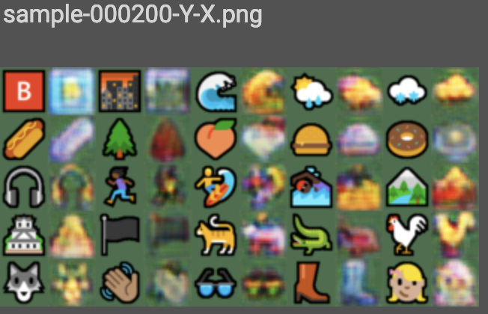

200 iterations of X-Y 200 iterations of Y-X

5000 iteration of X-Y 5000 iterations of Y-X

We can see that the color of the emoji is slightly different, and the detail of the emoji is less accurate and less clear.

I think those are because the cycle consistency loss is for helping find out the difference between the generated emoji and the original emoji and if it is too low or high it will affect the detail and resolution as well as the color.